Journal of Peace and Unification 00(0), pp.0-00
ISSN: 2233-9671© 2021 by Ewha Institute of Unification Studies
doi: https://doi.org/xxx.xxx

Title
Times New Roman-15.5

First name Last name ¹(Times New Roman -12)

^{First Author} Position, Affiliation, Country, Email: *****@*****.*****

Received on 05 October 2020. Reviewed on 09 October 2020. Accepted on 06 November 2020.

Abstract (Times New Roman - 13)
Less than 120 words. (Times New Roman - 10)

Keywords: 5 keywords

total less than 8,000 words

I. Introduction

Contents

II. Sub-title
Contents

Table 1. Title (Source or Compiled by the author)

A | B

III. Sub-title

Contents

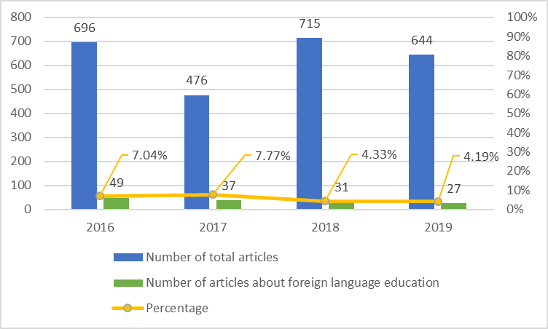

Figure 1. Title (Source or Compiled by the author)

IV. Sub-title

Contents

V. Conclusion

Contents

References

Baik, K. B. (2005). Leadership Review – Theory and Reality. Seoul, Korea: Changminsa.

